Experiment:19 Date:18/08/2027

Prolog Program for a Database with Name and DOB

Aim:
To create a Prolog database containing person's name and date of birth and retrieve the details.

Algorithm
- Start the program.
- Define facts containing name and date of birth.
- Store year, month, and day separately.
- Create a rule to retrieve the date of birth.
- Display the required person's date of birth.
PROGRAM:
person(aseem, 2004, 10, 15).
person(arun, 2003, 5, 20).
person(kumar, 2005, 8, 12).
person(priya, 2004, 12, 25).
find_dob(Name, Year, Month, Day) :-
person(Name, Year, Month, Day).
OUTPUT:
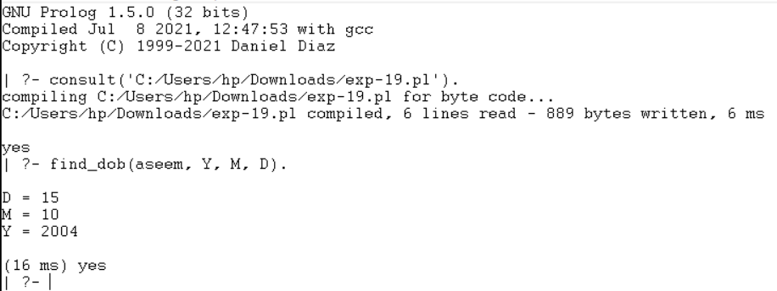

Result:
Thus, the Prolog program was successfully executed to store and retrieve name and DOB information.

